Electrochemical cells 14-09-2019

Electrochemistry is a branch of science, which studies conversion of chemical energy into electrical energy and vice versa or It is a branch of chemistry that studies chemical reactions which take place in a solution at the interface of an electron conductor (a metal or semiconductor) and an ionic conductor (an electrolyte) and which involve electron transfer between the electrode and the electrolyte or species in solution. The inter conversions of energies takes place through redox reactions form the basis of electrochemical cells.

Terminology used in electrochemical cell:
Anode- is the electrode at which oxidation occurs.
Cathode - is the electrode at which electrons are received from the outer circuit. It has a positive charge and is known as (+) in the cell diagrams.
Oxidation- is the loss of electrons or an increase in oxidation state by a molecule, atom or ion
Reduction - is the gain of electrons or a decrease in oxidation state by a molecule, atom, or ion.
Oxidation occurs at the anode and reduction occurs at the cathode.
The half-cell reaction at the anode is oxidation, while the half-cell reaction at the cathode is reduction.

Q-What are Electrochemical cells: Explain different types of electrochemical cells
The device, which converts chemical energy into electrical energy or electrical energy into chemical energy. There are two kinds of electrochemical cells, they are -
1. Galvanic cell or Voltaic cell: It is an electrochemical cell that produces electricity as a result of spontaneous redox reaction due conversion of chemical energy into electrical energy. Ex: Daniel Cell.
2. Electrolytic cell: It is an electrochemical cell in which non-spontaneous reaction is driven by an external source of current is called an Electrolytic cell (conversion of electrical energy into chemical energy)
Ex: Electro plating cell
Q- Describe the constriction and working of Galvanic cell or Voltaic cell
Galvanic cell consists of two electrodes dipped in two electrolyte solutions which are separated by a porous diaphragm or connected through a salt bridge. The Daniel cell is a typical example for the Galvanic cell (Fig. 1.1). This cell can be constructed by placing zinc rod in zinc sulphate solution and copper rod in copper sulphate solution. Electrical contact is provided between the two electrodes through salt bridge and externally connected by a wire through an ammeter or voltmeter. In this cell zinc rod is found to be negative (anode) and copper rod becomes positive (cathode). The electrons are sent out from the zinc rod to the copper rod, The

potential arising for anode is due to oxidation and it is referred as oxidation potential (E_{Zn/Zn}²⁺). Similarly the potential arising at cathode (copper) is due to reduction potential (E_{Cu}²⁺_{/Cu})
Daniel cell can be represented as:
→
Zn(s) /ZnSO₄ (aq) || CuSO₄ (aq) /Cu(s)
Cell reactions: When the zinc and the copper electrodes are connected externally connected, the following reactions are take place.
At anode or negative electrode (left electrode): Zinc goes into the solution as Zn²⁺ ions by liberation of electrons
Zn(s) → Zn²⁺(aq) + 2e⁻¹ (oxidation)………….(1.1)

Fig. 1.1
At cathode or positive electrode (right electrode): Reduction of Cu²⁺ ions take place with deposition of metallic copper on copper by consuming electrons
Cu²⁺(aq) + 2e⁻¹ → Cu(s) (reduction) …………..(1.2)
Addition of equation (1.1) and (1.2) gives redox or net chemical cell reaction is
Zn (s) + Cu²⁺(aq) → Zn²⁺(aq) + Cu (s) …………….(1.3)
For the above cell the emf is found to be 1.1 V at 25°C. The reaction is found to proceed spontaneously from left to right ie., electrode on the left forces the electrons into the external circuit and electrode on the right withdraws them. Therefore the emf of the cell is positive.
In Galvanic cell, emf can be expressed at the difference between two single electrode potential
The cell emf, E_{cell} = E_{cathode} – E_{anode …………………………..} (1.4)
When two electrodes are coupled to form a cell, the one with lower reduction potential value acts as anode and undergoes oxidation, the one with higher reduction potential value acts as cathode and under go reduction. For example in Daniel cell Zn-electrode has lower reduction potential value; hence it behaves as anode and undergoes oxidation. Where as Cu-electrode has higher reduction potential value, hence it behaves as cathode and undergoes reduction. In Zn-Hydrogen cell, Zn acts as anode, Hydrogen electrode acts as cathode. In Fe-Cu cell Fe -acts as anode, Cu- electrode acts as cathode.

Q - Write a note on cell notation or cell representation
In order to make it easier to describe a given electrochemical cell, a special symbolic notation has been adopted. If two electrodes are combined to form a cell, then the cell is represented by writing the electrode conventions side by side with the anode on the left and cathode on the right.
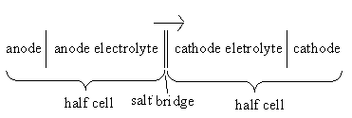
The half-cell in which oxidation occurs (anode) is always written on the left. The half-cell in which reduction occurs (cathode) is always written on the right. The vertical line indicates the phase boundary between the metal and solution. The two vertical lines represent salt bridge. An arrow indicates the flow of electrons form anode to cathode (Spontaneous reaction). The electrolyte may be represented by the formula of the whole compound or by ionic species by its concentration in bracket. By placing an ammeter in the external circuit, we can measure the amount of electric charge that passes through the electrodes, and thus the number of moles of reactants that get transformed into products in the cell reaction. Based on the above guidelines Daniel cell can be represented as:
→
Zn(s) /ZnSO₄ (aq) || CuSO₄ (aq) /Cu(s)

Q- What is salt bridge? Explain its function
Salt bridge is used to connect the oxidation and reduction half cells of a galvanic cell. Salt bridge is U-shaped glass tube filled with a relatively saturated inert electrolyte, usually potassium chloride or sodium chloride. Agar is used for jellification. The conductivity of the glass tube bridges depends on the concentration of the electrolyte solution. An increase in concentration below saturation increases the conductivity. Beyond saturated electrolyte content and narrow tube diameter are lower the conductivity.

Function of salt bridge:
- To avoid liquid junction potential.
- Bring about internal contact between the electrodes
- It keeps the solutions in two half-cells electrically neutral
- It connects the solutions of two half-cells and completes the cell circuit
- It prevents transference or diffusion of the solutions from one half-cell to the other

Q-Define the terms: electromotive force (emf) of the cell, standard electrode potential and single electrode potential (Reduction potential) or half-cell potential
Electromotive force (emf) of the cell : The difference in potential between the two electrodes of a galvanic cell which causes the flow of current from one electrode (higher potential) to the other (lower potential) as a result of spontaneous redox reaction is called emf of the cell or the cell potential and it is denoted by E_{cell}
The emf of the cell, E_{cell} = E_{cathode} - E_{anode} or E_{cell} = E_{right} – E_{left--------}(1.5)
Standard electrode potential: The potential that is developed when an element (metal or non-metal) is in equilibrium with a solution containing its own ions of unit concentration (1M) at 298 K is called standard electrode potential In case of gas electrode the gas at 1 atm. pressure, it is denoted by Eº_{cell}.

Single electrode potential (Reduction potential) or half-cell potential: ‘The potentialthet is developed at the interface between the metal and the solution, when it is in contact with a solution of its ions’. Or ‘it is a measure of tendency of a given half reaction to occur as reduction when it is in equilibrium with the other half cell’. It is denoted by E_{M}^{n+}/_{M}
For example the reduction potential of zinc electrode is E_{Zn}²⁺_{/Zn} = -0.76 V
Oxidation potential of zinc electrode is E _{Zn /Zn}²⁺ = 0.76V
Q: Discuss the origin of single electrode potential.
Origin of electrode potential: ‘The potential developed at the interface between the metal and the solution, when it is in contact with a solution of its ions’. When an electrode is in contact with a solution of its ions, such as in a half-cell, a potential arises due to the interaction between the two phases i.e. metal ion – metal electrode.
If a metal M dipped in a solution containing its ions M ^{n+}, following two reactions are possible.
- The metal shows the tendency to go into the solution as metal ions by losing electrons.
M(s) → M^{n+}(aq) + ne⁻¹ ( oxidation, loss of electrons)
- The metal ions in the solution show to tendency to get deposited as metal atoms.
M ^{n+}(aq) + ne⁻¹→ M(s) (reduction, gain of electrons)
Depending upon the nature of the metal, either the dissolution of the metal or the deposition of metal is faster in the beginning or the other one is slower. But after some time, the reaction will reach a state of equilibrium. M ^{n+}(aq) + n e ↔ M (s)
In this reaction the number of metal atoms dissolving is equal to the number of atoms getting deposited.
If the dissolution is faster than the deposition reaction, at equilibrium, the net change is a few metal atoms have dissolved in the solution, liberating electrons [M(s) → M^{n+}(aq) + ne⁻¹ ( oxidation, loss of electrons)]. These electrons accumulate on the electrode surface. Making it negatively charged [Fig. 1(a)]. The negatively charged electrode surface attracts a layer of positively charged ions at the interface, developing an electrical double layer called Helmholtz Electric double layer (HDL) across this double layer the potential develops and this potential is called single electrode potential.
Similarly, if the deposition reaction is faster than the dissolution, at equilibrium, the net change is deposition of few metal ions as metal atoms by consuming electrons [M ^{n+}(aq) + ne⁻¹→ M(s) (reduction, gain of electrons)]. As a result the electrode surface develops a layer of positive charge which attracts a layer of negatively charged ions at the interface [Fig. 1 (b)], again HDL is formed and develops single electrode potential. HDL is practically indistinguishable from the metal plane and may be visualized as parallel plane capacitor.
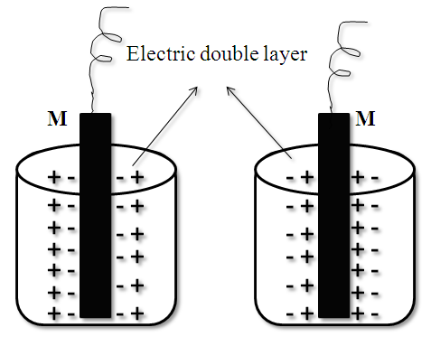

- (b)
Fig. 1
Q- What is the importance of electrochemical series (electrode potential?)
When elements are arranged in increasing order of their standard electrode potential values form a series called electrochemical series, called electrochemical series. Standard electrode potential values of some elements are given below.
M^{n+}/M Eº (V) M^{n+}/M Eº (V) M^{n+}/M Eº (V)
Li⁺/ Li -3.05 Al⁺³/Al -1.66 H⁺/H₂ 0.0
K⁺/K -2.93 Zn⁺²/Zn -0.76 Cu⁺²/Cu 0.34
Ba⁺²/Ba -2.90 Fe⁺²/Fe -0.44 Ag⁺/Ag 0.80
Ca⁺²/Ca -2.87 Cd⁺²/Cd -0.40 Hg⁺²/Hg 0.85
Na⁺/Na -2.71 Sn⁺²/sn -0.14 Pt⁺²/Pt 1.20
Mg⁺²/Mg -2.37 Pb⁺²/Pb -0.13 Au⁺³/Au 1.38
Electrochemical series gives the following valuable information.
- A negative value indicates oxidation tendency and a positive value indicates reduction tendency with respect to hydrogen.
- The metal with lower electrode potential is more reactive and as the electrode potential increases, the reactivity decreases and the metal with higher electrode potentials are nobler.
- Metals with lower electrode potentials have the tendency to replace metals with higher potential from their solutions.
- Metals with negative electrode potentials can be liberate hydrogen from acidic solutions.

Q- Derive Nernst equation for a single electrode (Thermodynamic concept of cell potential/electrode potential)
In 1889 WALTHER NERNST derived a thermodynamic equation, it relates the reduction potential of a half-cell (or the total voltage, i.e. the electromotive force, of the cell) at any point in time to the standard electrode potential (Eº), temperature (T), concentration of metal ion (M^{n+}) in solution and reaction quotient of the underlying reactions and species used.It is named after the German physical chemist WALTHER NERNST (1864-1941) who first formulated it, He received the Nobel prize in 1920 “in recognition of his work in thermochemistry”. His contribution to chemical thermodynamics led to the well known equation correlating chemical energy and the electric potential of a galvanic cell or battery.
In order derive this equation, free energy concept is used
Consider the following reversible electrode reaction
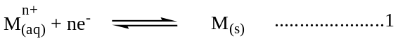
The free decrease energy change (-ΔG) in a spontaneous reaction is equal to the energy available to do work
(-ΔG)=W_{max} ------(2)
The maximum work available form a reversible chemical process is equal to maximum amount of electrical energy that can be obtained, W_{max} = W_{elec} -------(3)
W_{elec} is the maximum amount electrical energy that can be obtained and it is equal to the product of number of coulomb and energy available per coulomb and it is given by
W_{elec} = nFE -----(4)
The free energy change due to transfer of 1 mole of ions across the double layer is related to the electrode potential (E)
ΔG = -nFE……………….(5)
where n = the number of electrons involved in reaction; F= Faraday constant
The free energy change is also related to equilibrium constant (K). For a reversible reaction, the and change in free energy (ΔG) are inter related as
ΔG = ΔG⁰ + RT ln K --------------- (6)
Where R =Gas constant
T = Absolute temperature
ΔGº = Standard free energy change (ΔGº = - nFEº)
From equation (5) and (6)
-nFE = ΔG⁰ + RT ln K
-nFE = ΔG⁰ + RT ln[Product]\[Reactant]
-nFE = ΔG⁰ + RT ln [M]\[M^{n+}] since K = [M]\[M^{n+}]
E = Eº – RT/nF ln[M]\[M^{n+}]
= Eº – RT/nF ln[1]\[M^{n+}] ……………….(7) since [M] = 1
Equation (7) is basic Nernst equation. By substituting R (8.314 j K⁻¹ mol⁻¹) Faraday constant, F (965000 j v⁻¹mol⁻¹) and absolute temperature, T (298 K) and converting ln to log_{10,} the above equation further reduced to
E = E⁰ + 0.0591/n log [M^{n+}] ---------(8)
The Nernst equation for a cell: The Nernst equation can also be applied for calculation of emf of a cell.
For Daniel cell: Zn(s) /ZnSO₄ (aq) || CuSO₄ (aq) /Cu(s)
E_{cell =} {E^{O}_{Cu}²⁺_{/Cu} + 0.0591/n log [Cu²⁺]} –{E^{O}_{Zn}²⁺_{/Zn} + 0.0591/n log [Zn²⁺]}
E_{cell =} [E^{O}_{Cu}²⁺_{/Cu} – E^{O}_{Zn}²⁺_{/Zn}] + 0.0591 log [Cu2+/Zn²⁺]
E_{cell =} E^{O}_{cell} + 0.0591/2 log [Cu²⁺]/ [Zn²⁺]………….. (9)
In general-
0.0591 [Concentration of ionic species in cathode half cell]
E_{cell =} E^{O}_{cell} + _____ log ________________________________________________________
n [Concentration of ionic species in anode half cell]

Q- Discuss different types of Electrodes
Types of Electrodes: In electrochemical work, the various electrodes are used depending upon the purpose
1. Metal – metal ion electrode: This type of electrodes consists of a metal dipped in a solution containing its own ions. Ex: Zn/Zn²⁺, Cu/Cu^{2+s}
The electrode reaction can be written as M^{n+}(aq) + ne⁻ → M(s)
2. Metal – metal salt ion electrode (Metal – insoluble salt electrode): These electrodes consist of a metal in contact with a sparingly soluble salt of the same metal which is in contact with solution containing the anion of the salt. Ex: Calomel electrode (Hg/Hg₂Cl₂/KCl), Silver – Silver chloride electrode (Ag/AgCl/KCl) and Lead –lead sulphate electrode (Pb/PbSO₄/SO₄²⁻)
3. Gas electrode: Gas electrodes consist of a gas bubbling about an inert metal wire or foil, immersed in an ionic solution of the gas molecule.
Ex: H₂ – gas electrode (Pt /H₂ /H⁺)
Chlorine – gas electrode (Pt / Cl₂ / Cl⁻¹)
4. Ion selective electrode (Membrane electrode): In this type of electrodes, a membrane is in contact with
a solution, with which it can exchange ions.
Ex: Glass electrode (exchanges H⁺ ions with the solution), various metal ions selective
electrodes, which exchange metal ions with the solution.
Q- What are Reference Electrodes? Explain difference types of reference electrodes
Reference electrodes are those electrodes which have constant reduction potential and which are used determine the electrode potential of other electrode
There are two types of reference electrodes. They are -
- Primary reference electrode
- Secondary reference electrode
1. Primary reference electrode: The primary reference electrode used for cell potential measurements. The best primary standard reference electrode is standard hydrogen electrode (SHE), whose potential is taken as zero at all temperatures. However, it is not convenient for potential measurements. Because of that
i. Construction and working is difficult on account of difficulties involved in maintaining concentration of H⁺ ions at unity and in keeping the pressure of H₂-gas uniformly at 1 atm.
ii. The electrodes become inactive in the presence impurity gases present in hydrogen.
iii. It cannot be used in solution containing strong oxidizing agents (salts of MnO₄⁻¹, Cr₂O₇⁻²).
iv. In the presence of reducible ions or substances having positive electrodes, it cannot be used.

2. Secondary reference electrodes: Because of the difficulties involved in SHE as a reference electrode, some other electrodes of constant potential are used as reference electrode and these electrodes are called secondary reference electrodes, important potential are employed secondary reference electrodes are (i) Calomel electrode (ii) Silver – silver chloride electrode.
(i) Calomel electrode: Calomel electrode is a commonly used electrode containing of mercury and sparingly soluble mercurous chloride along with potassium chloride solution.
Construction: It is a metal-metal insoluble salt electrode, it consists of a glass tube with a side tube. Mercury is placed at the bottom of the tube. A paste of mercurous chloride and mercury is placed over the pool of mercury. The remaining part of the tube is filled with KCl solution. Platinum wire is dipped into the mercury layer for electrical contact. The side tube filled with KCl solution functions as a salt bridge (Fig. 1.3).
Notation of electrode: Calomel electrode can be represented as Hg(l)/Hg₂Cl₂;KCl(sat)
Electrode reactions: The calomel electrode can act as anode or cathode depending on the nature of the other electrode.
As Anode: when it acts as anode, the electrode reaction is
2Hg(s) → Hg₂²⁺(aq) + 2e⁻¹
Hg₂²⁺(aq) + 2Cl⁻¹(aq) → Hg₂Cl₂(s)
_____________________________
2Hg(s) + 2Cl⁻¹ (aq)→ Hg₂Cl₂(s) + 2e⁻¹
As Cathode: When it acts as cathode, the electrode reaction is:
Hg₂Cl₂(s) → Hg₂²⁺(aq) + 2Cl⁻¹ (aq)
Hg₂²⁺ (aq)+ 2e⁻¹ → 2Hg(s)
______________________________________________
Hg₂Cl₂(s)+ 2e⁻¹ → 2Hg(s) + 2Cl⁻¹(aq)
The net reversible reaction is: Hg₂Cl₂(s)+ 2e⁻¹⇔ 2Hg(s) + 2Cl⁻¹

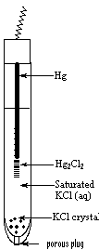
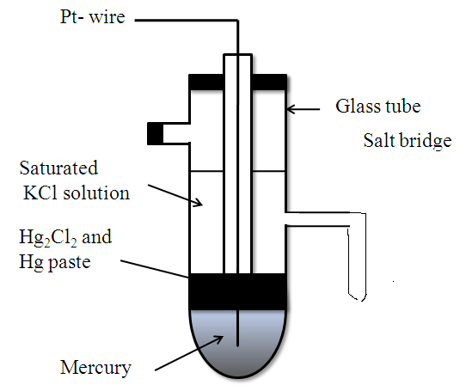

Or

Fig. 1.3
Reduction electrode potential E for a given KCl solution is given by the equation
E = E⁰ -0.0591/ n log K
E = E⁰ -0.0591/ n log [[Hg]²Cl⁻¹]²/[Hg₂Cl₂]
E = E⁰ -0.0591/ 2 log [Cl⁻¹]² since [Hg] = [Hg₂Cl₂] =1

Since the electrode is reversible with respect to chloride ion, the electrode potential depends on the concentration of KCl solution. The potential of the calomel electrode is found to depend on the concentration of KCl solution used in the half cell.
Concentration of the KCl solution E_{calomel} at 298K
0.1 N 0.3334 V
1.0 N 0.2810 V
Saturated 0.2422 V
Advantages of calomel electrode:
- It is very simple to construct.
- Potential is reproducible and stable
- Electrode potential doesn’t vary with temperature
Applications:
(i) Commonly used as reference electrode in all potentiometric determinations
(ii) Used as a secondary reference electrode in the measurement of single electrode potential
(iii) It is useful as a reference electrode in measurement of corrosion rate
(iv) Used as reference electrode in measurement of pH of solution
Q - Discuss determination of single electrode potential using secondary reference electrode (SCE)
Principle: It is impossible to measure the absolute value of a single electrode potential experimentally. Only the different in electrode potential between any two electrodes can be measured as emf of the cell formed by the combination of the electrodes. Hence electrode potential value are assigned for different electrodes with respect to the standard hydrogen electrode [H⁺ (1M) / Pt, H₂ (1atm)] whose potential is arbitrary taken as zero at all temperatures. The single electrode potential of an unknown can also be determined by using secondary reference electrodes like calomel or Ag-AgCl electrode.
Determination of Single electrode potential using calomel electrode:
The potential of a given electrode is measured using saturated calomel electrode (SCE) whose potential is accurately known. The electrode whose potential to be determined is coupled with calomel electrode as shown in fig. The emf of the cell is determined using an electronic voltmeter (Fig.1.5), Ex: In determination of electrode potential of Zinc, Zn electrode is coupled with a saturated calomel electrode through salt bridge. The cell assembly can be represented as
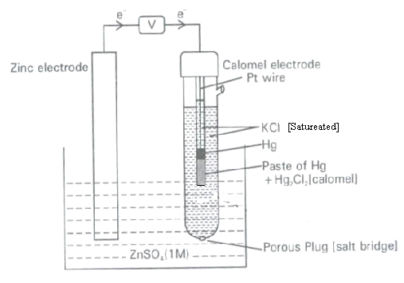
Fig. 1.5
Zn / Zn²⁺ || KCl (sat)/ Hg₂Cl_{2/}Hg
Calculation of E_{cell} = E _{cathode -} E_{anode}
= E_{SCE} – E_{Zn2+/Zn}
= 0.241 - E_{zn2+/Zn}
Therefore, E_{zn2+/Zn} = 0.241 - E_{cell}

Q: What is ion- selective or membrane electrode? Explain principle, construction and working of glass electrode.
Ion selective or membrane electrode: Ion selective electrode is one which selectively responds to specific ion in a mixture and the potential developed at the electrode is a function of the concentration of that ion in the solution. Ion selective electrodes make use of a kind of membrane which is sensitive to a particular chemical species. Therefore, these electrodes are also known as membrane electrodes. The electrode generally consists of a thin membrane which is capable of exchanging the specific ion with the solution it is in contact.
There are four kinds of membranes. They are-
1. Glass membrane
2. Solid state membrane
3. Heterogeneous membrane
4. Liquid membrane
Glass electrode: (No construction details)
Principle: If solutions of different pH are separated by a thin membrane, the potential develops across the membrane. The magnitude of potential depends on the difference in pH of two solutions. If pH of one of these is held constant, the observed glass electrode potential is a linear function of pH of the second solution.
Construction: Glass electrode is an ion selective reference electrode. It consists of a thin walled glass bulb of special type with high electrical conductivity with low melting point. A portion of the bulb is filled with a solution of constant pH (0.1 M HCl). Ag-AgCl electrode is dipped to provide electrical contact (Fig. 1.6).
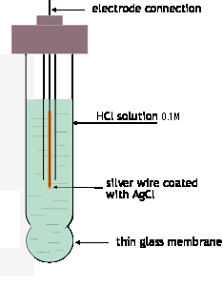
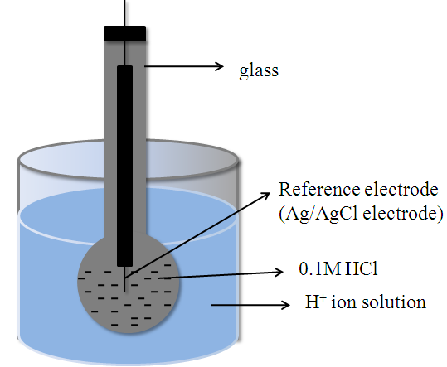
.

Fig.1.6
Notation of the electrode potential: Glass electrode can be represented as Ag/AgCl (s)/0.1 M HCl / glass
When glass membrane (SiO₂ – CaO - Na₂O) dipped in solution of unknown pH, glass membrane exchanges its cations which are bound on silica network with H⁺ ions
Na⁺Glass⁻ + H⁺ ⇔ H⁺Glass⁻ + Na⁺
(glass membrane) (solution) (glass membrane) (solution)

Electrode potential of Glass electrode: The potential of the glass electrode E_{G} has three components

- The boundary potential (E_{b})
- The potential of the internal Ag/AgCl reference electrode (E_{ref)}
- A small asymmetry potential (E_{asy})
E_{G} = E_{b} + E_{ref} + E_{asy} ---------(1)
When the glass electrode is placed in a test solution, a potential is developed across the membrane. The potential difference at the interface E_{b} is the result of the difference in potential E₁ – E₂ across the membrane between the two liquids.

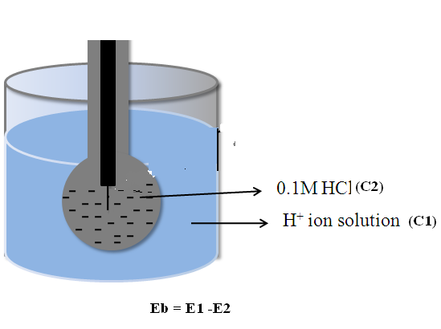

E₁ = J₁ – 0.0591 / n log C₁ and E₂ = J₂ – 0.0591 / n log C₂
Where J1 and J2 are constants, C₁ and C₂ are concentration of H⁺ ions at the external and internal surface of the glass membrane. Since the glass at inner and outer solutions is identical J₁ = J₂ Then E_{b} = E₁ – E₂, where E_{b} is the boundary potential
E_{b} = 0.0591 log C₁/C₂
= 0.0591 log C₁ – 00591 log C₂
Since the concentration of inner solution is constant C₂ is constant. So that above equation becomes
E_{b} = L¹ + 0.0591 log C₁

= L¹ + 0.0591 log [H⁺]

Where L₁ = - 0.0591 log C₂
Substitute E_{b} in equation E_{G} = E_{b} + E_{ref} + E_{asy}
= L¹ + 0.0591 log [H⁺] + E_{ref} + E_{asy}
E_{G} = E_{G}⁰ – 0.0591 pH where E_{G}⁰ = L¹ + E_{ref} + E_{asy}
E_{G}⁰ is specific to a particular glass electrode.
Q- What are the advantages and disadvantages of glass electrode?
Advantages: (1) It is simple and can easily be operated.
- Equilibrium is rapidly achieved
- Accurate results are obtained between pH 1-9 ranges.
- It is does not easily poisoned
- It can be used in oxidizing and reducing environments.
Disadvantages: (1) It can be used for solutions with pH range only from 0 to 10. Above pH 10, solution, electrode becomes sensitive to Na⁺ ions and leads to alkaline error.
(2) Membrane of glass though very thin renders high resistance which cannot be measured by ordinary potentiometers. Therefore it is necessary to use electronic potentiometers.
Q- Explain determination of pH of an unknown solution using glass electrode.
Glass electrode is used as the internal reference electrode for determining the pH of solution especially colored solution containing oxidizing or reducing agents. Calomel electrode is used as the secondary reference electrode. To determine the pH of the given solution, the glass electrode is placed in the test solution and this half cell is coupled with saturated calomel electrode (Fig. 1.7). The glass electrode acts as anode calomel electrode behaves as cathode. The cell assembly is represented as-
Glass/Ag-AgCl/ HCl (0.1M/ Test solution (pH = ?) || KCl (Sat) / Hg₂Cl₂/Hg
The emf of the cell is determined potentiametrically (pH meter)
E_{cell} = E_{cathode} – E_{anode}
= E_{calomel} - E_{Glass}
= E_{calomel –} [E_{G}⁰ – 0.0591 pH] [since E_{G} = E_{G}⁰ – 0.0591 pH]
0.0591pH = E_{cell} - E_{calomel} + E_{G}⁰
Or pH = E_{cell} – 0.241+ E_{G}⁰/ 0.0591
[since Electrode potential of saturated calomel is 0.241 V]
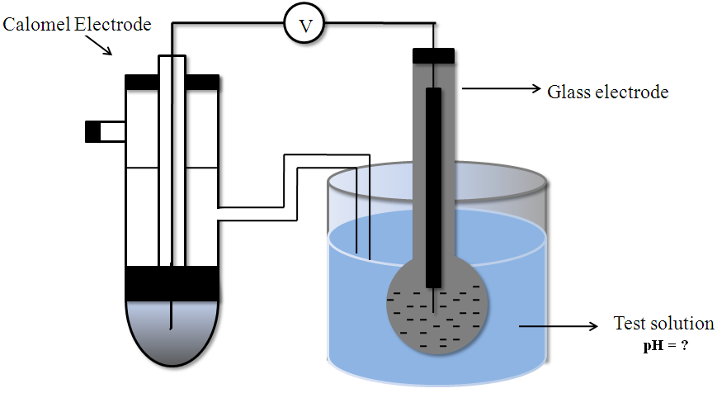
Fig. 1.7
E_{G}⁰ value of the glass electrode is evaluated by dipping the glass electrode in a solution of known pH and measuring the emf of the cell formed when combined with a calomel electrode.
Q- What are concentration cells? Explain with suitable example
From study of thermodynamics you may recall that the process
solute (concentrated) → solute (dilute)
is accompanied by a fall in free energy, and therefore is capable of doing work on the surroundings; all that is required is some practical way of capturing this work. One way of doing this is by means of a concentration cell. The electrode potential of a half cell dependent on the concentration of the electrolyte with which the electrode is in contact. In concentration cell, two similar metal electrodes are in contact the solutions of its own ions at different concentration, resulting in difference in the electrode potential. So, the concentration cell is a type of Galvanic cell, in which electrodes of the same metal are in contact with solutions of its own ions with different concentration. The emf arises due to the difference in concentrations of solutions.
For example: M(s) / M^{n+} (C₁)|| M^{n+}(C₂) / M(s)
where C₁ and C₂ are molar concentration of Mn^{n+} ions in the two half cells respectively.
The concentration cell reaction is written as
At anode (oxidation) M(s) → M^{n+} (C₁) + ne⁻¹
At cathode (reduction) M^{n+} (C₂) + ne⁻¹ → M(s)
Adding the two half-cell reaction (redox or net cell reaction or overall cell reaction
M^{n+}(C₂) → M^{n+}(C₁)
The concentration of M^{n+} ions in the anode solution increases and that of the cathode solution decreases until both electrode solutions attain the equal concentration.
A typical concentration cell is illustrated as follows. Cu(s) / Cu²⁺ (C₁)|| Cu²⁺(C₂) / Cu(s)
In this concentration cells, two copper electrodes are immersed in copper sulphate solutions of concentrations C₁ and C₂ (Fig. 1.8). By convention, the left hand electrode is the anode and the right hand electrode is cathode. The following reactions are takes place in the copper concentration cell.
At anode (oxidation) Cu (s) → Cu²⁺ (C₁)+ 2e⁻¹
At cathode (reduction) Cu²⁺ (C₂) + 2e⁻¹ → Cu(s)
_______________________________
Net cell reaction Cu²⁺ (C₂) → Cu²⁺(C₁)
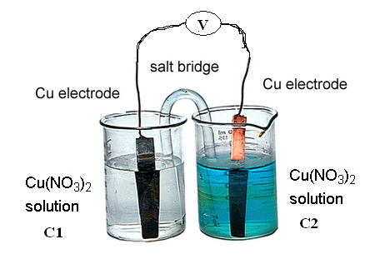
Fig. 1.8
The emf of the concentration cell can be represented as
E_{cell} = {E⁰ + 0.0591/n log [C₂]} - {E⁰ + 0.0591/n log [C₁]}
E_{cell} = 0.0591/n log [C₂] / [C₁] at 298 K, where C₂ > C₁
It may be noted that the term Eº does not appear in the equation since it gets cancelled
From the above equation, we can conclude the followings
1. When two solutions are at the same concentration log [C₂] / [C₁] = 0 and hence no electricity flows.
2. When C₂ > C₁ or [C₂] / [C₁] > 1, log [C₂] / [C₁] is positive. So that E is positive. Thus the direction of spontaneous reaction is from the more concentration solution C₂ to less concentration solution C₁.
3. Higher the ratio of [C₂] / [C₁], higher is the value of cell potential. For ex: If the ratio of [C₂] / [C₁] increases from 0.001 M to 0.01 M (i.e 10 times) the voltage doubles and if the ratio increases 100 times, the voltage becomes three times.
4. When C₂ < C_{1,} log [C₂] / [C₁] is negative, so that E is negative. Thus the ceil reaction is non-spontaneous.

Q-Derivation of Nernst equation for concentration cell (for Example –Ag concentration cell)
- Two silver rods are dipped in silver nitrate solutions of concentrations C₁ and C₂ respectively,
- The cell may be represented as: Ag_{(s)}⏐AgNO₃ (C₁)⏐⏐ AgNO₃ (C₂)⏐ Ag_{(s)}. Where C₂ > C₁.
- The electrode reactions are:
At anode: Ag_{(s)} → Ag⁺(C₁) + e⁻
At cathode: Ag⁺(C₂) + e⁻→ Ag_{(s)}
- The EMF of the above cell is: E_{cell} = E_{cathode} -E_{anode}
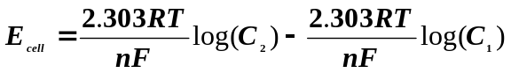
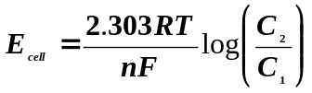 (or) 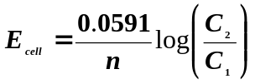; at 298 K
Where C₂ > C₁
Note – E⁰ does not appear in Nernst equation of a concentration cell because it gets cancelled.

REVIEW QUESTIONS
.
1) Define the term single electrode potential. Describe the origin of single electrode potential.
2) What is single electrode potential? Derive Nernst equation for singe electrode potential
3) What are ion selective electrodes? Explain determination of pH of a solution using a glass electrode.
4) Explain the terms with examples (i) galvanic cell (ii) half cell.
5) What are reactions that occur at the electrodes of a galvanic cell? Explain by taking Daniel cell as an
example.
6) What are galvanic cells, electrolytic cells, reversible and irreversible cells?
7) How potential of an electrode measured using a calomel electrode?
8) Why the anode of a galvanic cell is negative and cathode is positive? Write different electrode reactions occur at the electrodes.
9) Explain the method of determination of pH of a given solution using glass.
10) Describe the construction of calomel electrode. Mention the advantages of this reference electrode.
11) What are ion selective electrodes. Give examples?
12) Describe the role of salt bridge in the Denial cell.
13) Discuss the construction of a calomel electrode with relevant chemical reactions. What are the advantages?
14) What are concentration cells? Derive an expression for the e.m.f. of a concentration
15) Justify the following statements
(i) In a galvanic cell anode is –ve and cathode is +ve.
(ii) The emf of a cell is always positive.
(iii) A salt bridge is used in the construction of a Galvanic cell
(iv) Ordinary volt meter are not used in the voltage measurement of Galvanic cell.
(v) In a concentration cell, no electricity flow when the concentration of metal ion is same in both the half cell.
16) A cell is constructed by coupling Zn-electrode dipped in 0.5 M ZnSO₄ and Ni-electrode dipped in
0.05 M NiSO₄. Write the cell representation and cell reactions. Calculate emf of the cell. Given:
standard reduction potentials of Zn and Ni are -0.76 and -0.25 V respectively.
17). Calculate the voltage generated in the following cell Fe/Fe²⁺|| Mn²⁺/Mn. When iron rod is immersed in
1.0 M FeSO₄ solution and Mn rod is immersed in 0.1M MnSO₄ solution. Given E⁰ for Fe²⁺/Fe is -0.4V and Mn²⁺/Mn is -1.18V.
18) What is single electrode potential? Calculate the emf of the Cell Fe/Fe²⁺(0.01)║Ag⁺(0.1)/Ag at 298 K, if standard reduction electrode potentials of Fe and Ag electrodes are -0.44 and 0.8 V respectively.
19). A cell is formed by placing two copper electrodes immersed separately in cupric sulphate solutions of which one is 100 times more concentrated than the other. Write the cell reactions and calculate the potential at 298 K.
20) A concentration cell was constructed by immersing two silver electrodes in 0.05 M and 0.1 M AgNO₃ solution. Write cell representation, cell reactions and calculate the emf of the concentration cell.
21) What is standard electrode potential? The spontaneous galvanic cell -
Tin/Tin ion (0.024 M)║ Tin ion (0.64 M)/Tin develops an emf of 0.0126 V at 25 ^{O}C. Calculate the valency of tin.
22) Write the electrode reactions and calculate the emf of the following cell at 298K Given E^{O} cell =1.3 V.
Cu (s)/Cu² ⁺ (1 x 10⁻² M) ║Ag⁺ (1 x 10⁻¹ M)/Ag (s)
23) What are concentration cells? Calculate the emf of the following cell at 298K Ag(s)/Ag⁺ (0.01M)║Ag⁺
(0.1M)/Ag(s)
24). A cell uses Zn²⁺/ Zn and Ag⁺/Ag electrodes. Write the cell representation, half cell reactions and net cell
reaction. Calculate the emf of the cell. Given E^{O} _{Zn}²⁺_{/ Zn} = -0.76 V; E^{O} _{Ag}+ _{/Ag} = 0.8V.
25). Calculate the emf of a cadmium-copper cell in which Cd is in contact with 0.002 M CdSO₄ and Cu in contact with 0.02M CuSO₄ solution. The E⁰_{cell} =0.74V at 298K.

- Amalgam electrode: These types of electrodes consist of metal-amalgam, it is in contact with a solution containing its own ions.
Ex: Lead amalgam electrode (Pb – Hg / Pb²⁺)
- Oxidation – reduction electrode:
In these types of electrodes the potential arises from the presence of oxidized and reduced forms of the same substance in solution. The potential developed is picked up by an inert electrode like platinum.
Ex: Pt/Fe²⁺, Fe³⁺
Pt/Ce³⁺, Ce⁴⁺
Pt/Sn²⁺, Sn⁴⁺

Classification of Galvanic Cells:
Galvanic Cells are classified into three types. They are
  - Primary (Irreversible) cells
  - Secondary (reversible) cells
  - Concentration cells
- Primary (Irreversible) cells: In this type, the cell reaction is not reversible. They are not rechargeable. Hence once discharged, they have no further electrical charge. Ex: Dry cell.
- Secondary (reversible) cells: In this type, the cell reaction is completely reversible and rechargeable. Ex: Daniel cell, Ni – Cd cell.
- Concentration cells: In this type, the electrodes of the cell are made up of the same metal and two solutions in which the electrodes are dipped only different concentrations.
Ex: Cu(s) / Cu²⁺ (C₁)|| Cu²⁺(C₂) / Cu(s) , where C₁ and C₂ are molar concentration of Cu²⁺ ions in the
two half cells respectively.
Differences in electrolytic cell and galvanic cell

.
electrolytic cell | galvanic cell
Electrical energy is converted into  chemical energy  Anode positive electrode. Cathode  negative electrode.  Ions are discharged on both the electrodes.  If the electrodes are inert, concentration of  the electrolyte decreases when the electric  current is circulated. | Chemical energy is converted into  electrical energy.  Anode negative electrode. Cathode  positive electrode.  Ions are discharged only on the cathode.  Concentration of the anodic half-cell  increases while that of cathodic half-cell  decreases when the  two electrodes are

